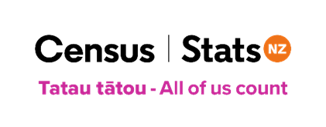
2023 Census – Rainbow communities
January 2023
Publishers note: This information was created by Stats NZ in consultation with Intersex Aotearoa. It can be shared or reproduced with appropriate references made.
Introduction
The New Zealand Census of Populations and Dwellings is the official five-yearly nationwide survey of everyone in Aotearoa and the places they live or stay.
The next census is on 7 March 2023.
For the first time, the census will ask questions about gender, sexual identity, and variation of sex characteristics (generally known as intersex).
It’s important that the census represents all the people of Aotearoa New Zealand. The collection of this information will enable groups and individuals to use census data to advocate for the needs of Rainbow communities, the same as for every New Zealander.
By taking part in the census, you help create a better understanding of your community and what it needs. People’s responses are combined to produce statistics that provide a picture of life in Aotearoa New Zealand and how it is changing.
Just as for other information collected in the census, it will be important to get good quality responses to these new questions to ensure that the data is able to be used by communities and decision makers.
Completing the census
The census can be completed either online or on a paper form.
The new and updated questions relating to gender, sex at birth, sexual identity, and variation of sex characteristics are asked in four different questions. On the paper forms these are:

Question 3
Question 3 asks, ‘What is your gender?’
There is a graphic image saying ‘Mark your answer like this:’ followed by an image of an oval with a horizontal line through it.
Response options are:
- male
- female
another gender. Please state below: free text response.

Question 4
Question 4 asks, ‘What was your sex at birth? For example, what was recorded on your birth certificate.’
Response options are:
- male
- female.

Question 29
Question 29 asks, ‘Which of the following best describes how you think of yourself?’
Response options are:
- heterosexual / straight
- gay or lesbian
- bisexual
- another identity. Please state below: free text response.
or
- prefer not to say.

Question 30
Question 30 asks, ‘Were you born with a variation of sex characteristics (otherwise known as an intersex variation)?’
Response options are:
- yes
- no
- don’t know
or
- prefer not to say.

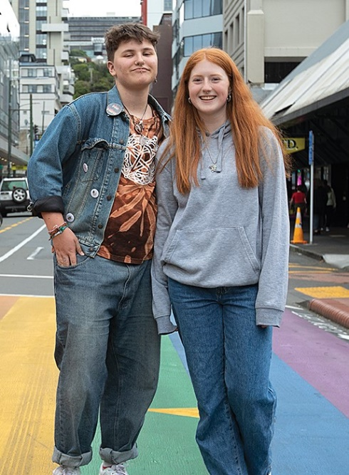
Gender refers to your social and personal identity as a male, female, or another gender or genders that may be non-binary. There is space in the form to write your gender in.
Sex at birth refers to the sex that was recorded for you when you were born, for example on your birth certificate.
Collecting both gender and sex at birth information will give us data that will better reflect the diversity of Aotearoa New Zealand, and also enable the production of more accurate and detailed information across population groups.
Sexual identity data will provide important insights about how social outcomes may vary by sexual identity.
Variation of sex characteristics refers to genetic, hormonal, or physical sex characteristics that do not typically fit within social or medical expectations of female or male bodies – often referred to as being intersex. For more information about this, please refer to our Variation of Sex Characteristics factsheet. This is also available in Large Print Word format.
Privacy and confidentiality
If you are concerned about privacy and have not come out to those in your household, you may want to fill out your Individual Form in private, in a different room, or at a later time. You can complete your census form at any time during the census period.
If completing your census form online, no one else in your household will be able to view it once you submit it. You will know it has been submitted securely when you see ‘Done’ beside your form on the ‘Household overview’ page.
Once submitted, your information is stored on a secure data storage server certified for use by the New Zealand Government.
Published census data is always about groups and communities, never individuals. All identifying information, such as names and addresses, is removed before anyone can use the data.
Find out more about census
Visit our website www.census.govt.nz for more information.

