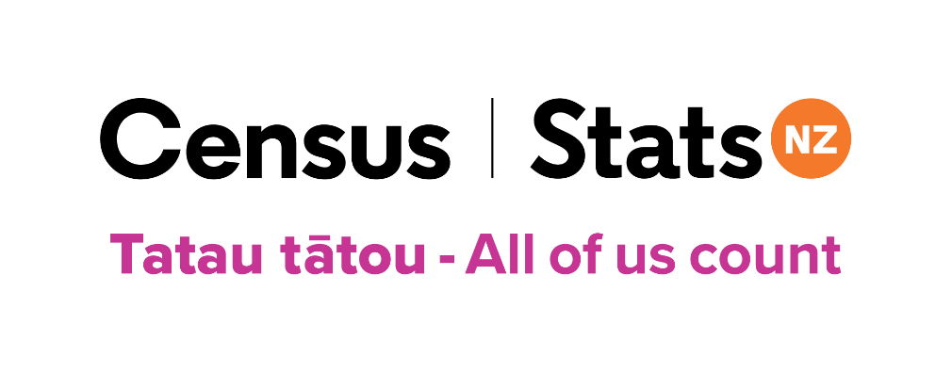
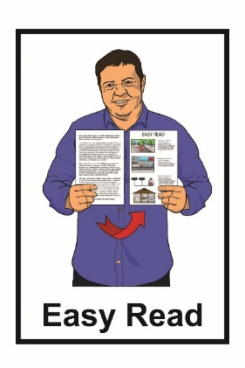

E wātea tonu ana he wā

hei whakakī i te Tatauranga 2023
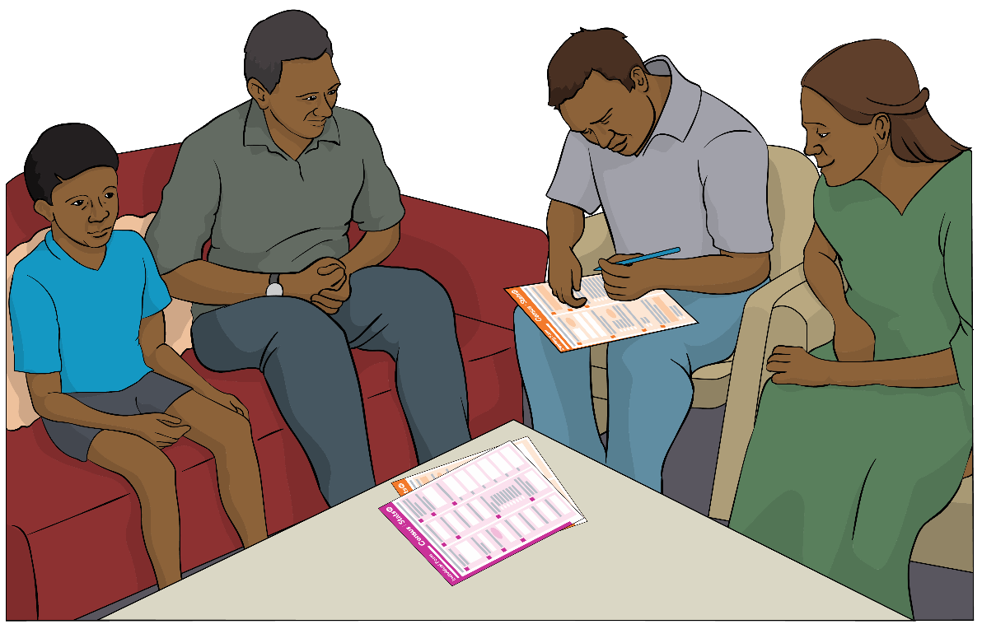

Tatau tātou - All of us count

He aha ngā kai o roto i tēnei puka

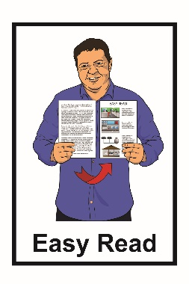
Nama whārangi:

Mō te aha tēnei pukapuka............... 3

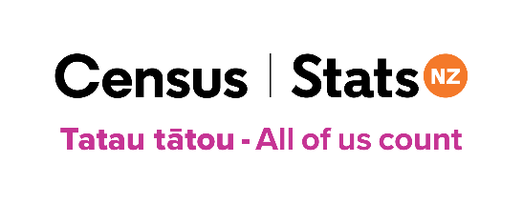
He aha te tatauranga....................... 4

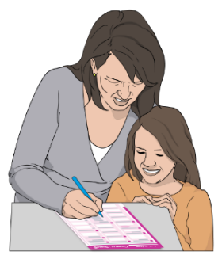
Mehemea kua whakakīia kētia e koe ō puka tatauranga............................ 7

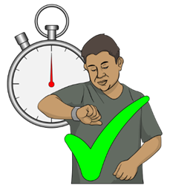
Kāore anō kia mutu, ka taea e koe te whakakī i te tatauranga................... 9

He mōhiotanga mō Huripari
Gabrielle……………….….............. 10
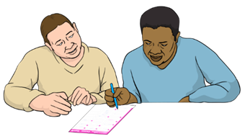

Te kimi tautoko hei whakakī i
ō puka tatauranga 12
Nama whārangi:
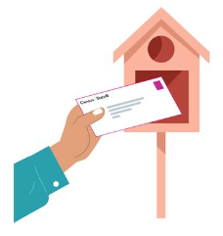

Ka pēhea koe e whiwhi ai i
ō puka tatauranga...........................17

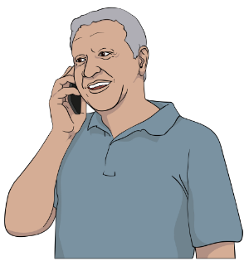
Me pēhea te whakapā mai ki te tīma tatauranga......................................19

Mō te aha tēnei pukapuka

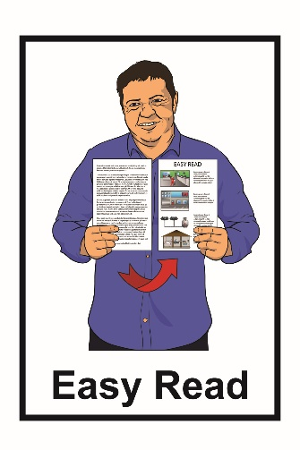
Kei tēnei pukapuka ētahi whakamārama mō:

          - ngā āhuatanga me mahi e koe mehemea kāore anō koe kia whakakī i te Tatauranga 2023

          - ngā panonitanga ki te Tatauranga 2023 nā Huripari Gabrielle.

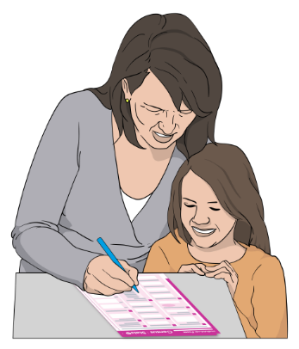
Ko tēnei mea te tatauranga he wā e pātaingia ai koe mō ngā mea pēnei:
- ko wai koe
- tokohia ngā tāngata e noho tahi ana me koe.

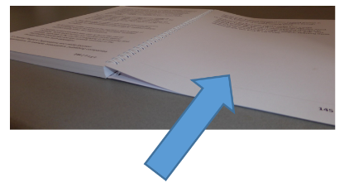
Ka taea e koe ētahi atu kōrero te kite mō te āhua o te tatauranga kei ngā whārangi 5-6 o tēnei pukapuka.

Kua oti tēnei mōhiotanga te tuhi e Tatauranga Aotearoa.

Ko Tatauranga Aotearoa te hinonga kāwanatanga e whakahaere ana i te Tatauranga 2023.

He aha te tatauranga?

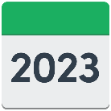
Ko tēnei mea te tatauranga:

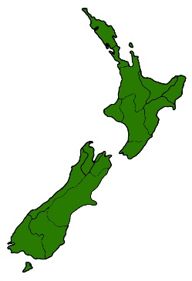
- ka mahia ia 5 tau

- he pēhea tātou e kimi kōrero ai mō ngā tāngata kei Aotearoa.

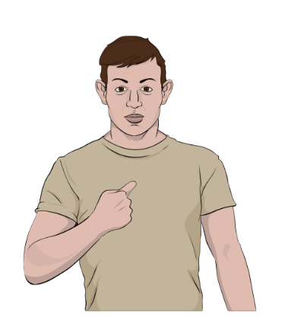
Ka mahia te tatauranga mā te whakamahi i ngā puka e pātai ana i ētahi pātai:
- mōu
- mō te wāhi e noho nā koe.

Ka taea e koe te mahi i te tatauranga mā te whakakī i:
- ētahi puka tuihono tēnei rānei

- ētahi puka pepa.
Ko ngā mōhiotanga tatauranga ka whakamahia hei whakamahere i ngā mea pēnei i:

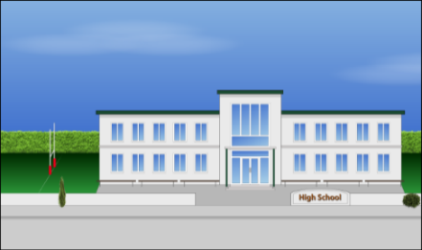
- te taurimatanga hauora
- ngā kura
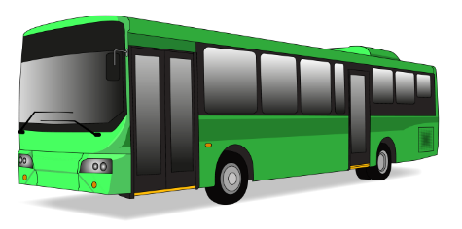
- te whai whare
- ngā pahi me ngā tereina
- te hanga rori

- ngā whare mō te iwi whānui pēnei i ngā whare pukapuka.

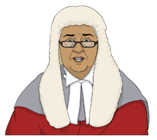
E kī ana te ture me whakakī ngā tāngata katoa i Aotearoa i te tatauranga.

Mehemea kua whakakīia kētia e koe ō puka tatauranga
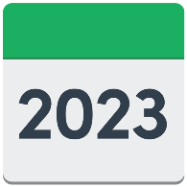
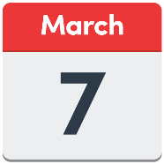

I tū te rā Tatauranga i te Rātū 7 Poutūterangi 2023.
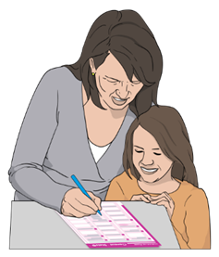
Mehemea kua whakakīia kētia e koe ō puka tatauranga, kāore ō mahi
ināianei.

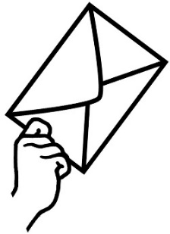
Ka whiwhi tonu pea koe i tētahi reta whakamahara mai i Tatauranga Aotearoa.

Ētahi pūtake e tae atu ai pea tētahi reta whakamahara ki a koe, mehemea:

- kāore anō kia oti i a koe ō puka pepa tatauranga

- kua whakahokia mai he puka pepa engari kāore anō kia tatauria e Tatauranga Aotearoa.

Mehemea kua whakakīia kētia e koe ō puka tatauranga:

- kaua e aro atu ki te reta whakamahara
- ehara i te mea me mahi anō koe i te tatauranga.

Kāore anō kia mutu, ka taea e koe te whakakī i te tatauranga

I tū te rā Tatauranga i te Rātū 7 Poutūterangi 2023.

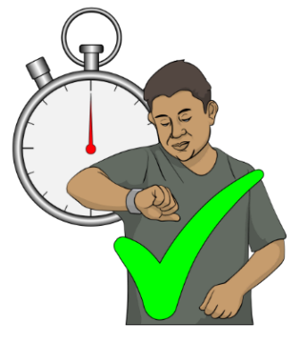
Mehemea kāore anō koe kia whakakī i ō puka tatauranga, kāore anō kia mutu, ka taea e koe te whakakī i te tatauranga.

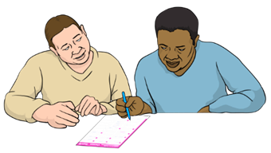
Ka taea tonutia e koe te whakakī puka tatauranga i muri i te Rātū, 7 Poutūterangi 2023.

Whakautua ngā pātai tatauranga mō te wāhi i noho nā koe i te Rātū 7 Poutūterangi 2023.

He mōhiotanga mō Huripari Gabrielle

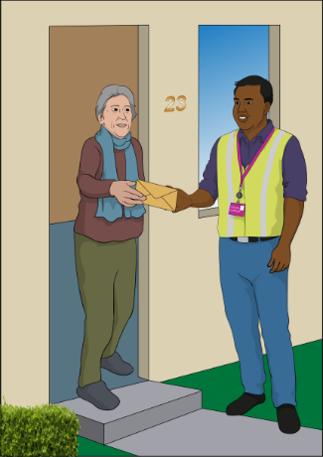
Mehemea kua pāngia koe e Huripari Gabrielle:

- ka roa kē atu te wā mōu ki te whakaoti i te tatauranga
- ka whai tautoko koe kia whai wāhi ki te tatauranga.

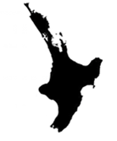
I tino tukia ētahi rohe o Te Ika-a-Māui e Huripari Gabrielle i te marama o Huitanguru 2023.

I ētahi rohe o te Ika-a-Māui:
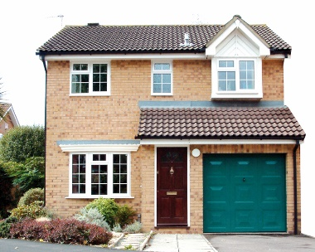
- kei te hē tonu ētahi o ngā huarahi

- he maha ngā tāngata kāore anō kia āhei te hoki ki ō rātou kāinga.

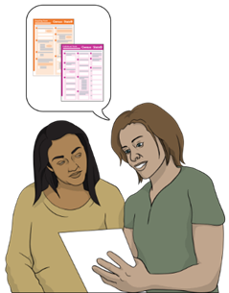
Ka taea koe te āwhina kia whai wāhi ai koe ki te tatauranga, kia rite mai koe.

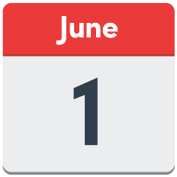
Ka peka atu ngā kaikohikohi tatauranga. ki te hunga i pākia e Huripari Gabrielle taea noatia te 1 Pipiri 2023.

Ka mahi tahi ngā kaihautū ā-iwi me ngā rōpū hapori ki te tuku tautoko i ia rohe.

Ka whakaritea hoki he wāhi, he rā hoki i te hapori mā te tangata kia pai ai te haere ki reira ki te kimi tautoko mō te mahi i te tatauranga.

Te kimi tautoko hei whakakī i ō puka tatauranga
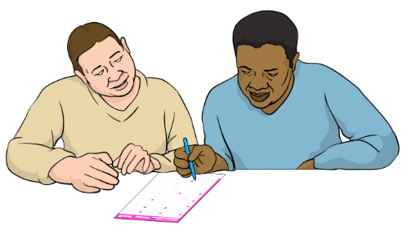
Ki te hiahia koe ki ētahi tautoko hei whakakī i te puka tatauranga ka taea e koe te pātai ki tētahi tāngata pēnei i tētahi:
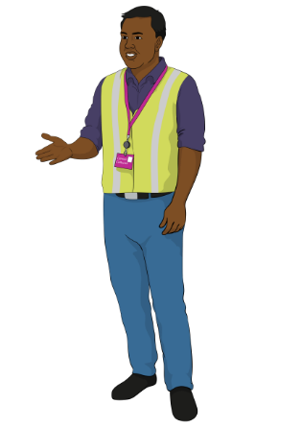
- hoa
- mema whānau
- kaikohikohi tatauranga.

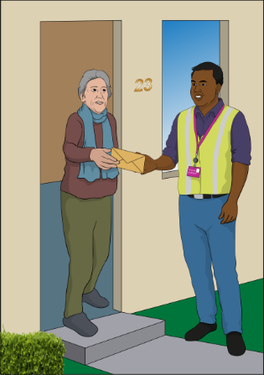
Ko tēnei mea te kaikohikohi tatauranga he tangata ka āhei pea ki te:

          - haere atu ki tō kāinga

          - tautoko i a koe kia mārama koe ki ngā mōhiotanga i roto i tēnei pukapuka

          - tautoko koe ki te whakakī i ō puka tatauranga.

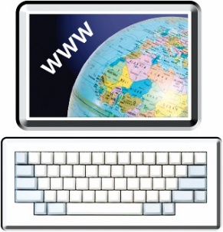
Kei ēnei wāhi ka wātea te ipurangi ki a koe, me tētahi rorohiko hei whakakī tuihono (ā-ipurangi) i te tatauranga:

- Te Whare Pukapuka
- Te Pokapū Whakahoki Pātai

- Manaakitanga Kaumātua

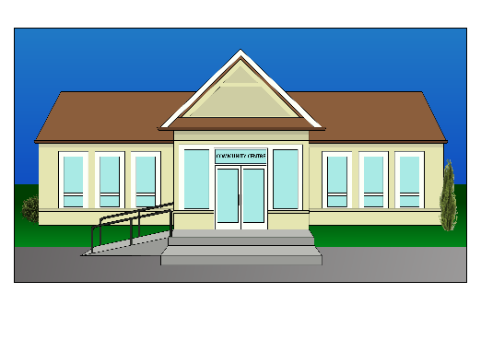
- te rōpū o Senior Net

- te pūtahi mōhiotanga o I-Site

- te tari o Tāngata Turi Aotearoa.

Ka taea e koe te kimi kōrero mō ngā wāhi me ngā rā hapori i tō rohe mā te peka atu ki te paetukutuku o te tatauranga:

www.census.govt.nz/census-support

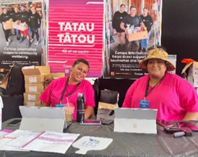
Ka tae atu te tira tatauranga ki ngā rā hapori.

Kei te tira tatauranga ētahi:

- puka pepa mā te hunga e hiahia ana ki te whakakī i te tatauranga ki te pepa
- he pūrere pēnei i tētahi paparorohiko/ iPad mā te hunga e hiahia ana ki te whakakī tuihono i te tatauranga.

Ehara i te mea me mau mai koe i tētahi atu mea.

Kei a mātou ngā mea tika katoa hei whakaoti māu i te tatauranga.

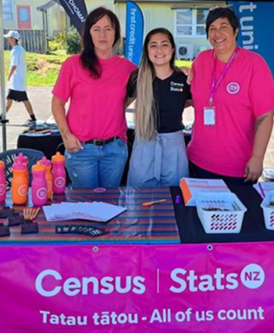
Mehemea he mōkihi tatauranga tāu e pai ana kia haria mai e koe ki tētahi rā hapori, ki te hiahia koe.

Kei tētahi mōkihi tatauranga pea ēnei mea:
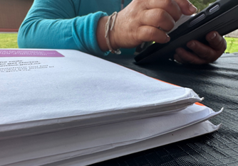
- he reta mō te tatauranga

- ō puka tatauranga.

- he mōhiotanga mō te tatauranga.

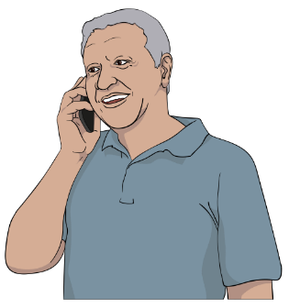
Ka taea e koe te whakapā mai ki te tira tatauranga ki te tono i tētahi kaikohikohi tatauranga kia āwhina i a koe.

Kei ngā whārangi 18 ki 21 i tēnei puka ka kitea e koe ētahi mōhiotanga mō te kōrero ki te tira tatauranga.

Ka pēhea koe e whiwhi ai i ō puka tatauranga
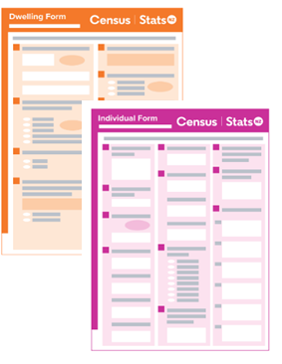
Kua whiwhi te nuinga o te tangata i ō rātou mōkihi tatauranga mā te mēra.

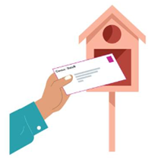
Ka pōturi kē atu ngā ratonga mēra o ētahi takiwā nā te:
- waipuke
- takoto hē o ngā huarahi.

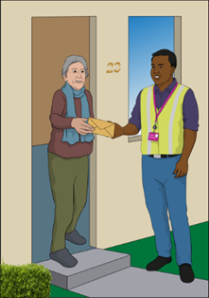
Ka haria atu ō rātou mōkihi tatauranga ki ētahi tāngata e tētahi kaikohikohi tatauranga.

Ka taea tonutia e ngā kaikohikohi tatauranga te peka atu ki ngā wāhi he haumaru mō rātou te haere mā ngā huarahi.
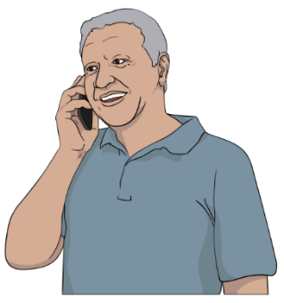
Tēnā whakapā mai ki te tira tatauranga mehemea:

- kāore anō koe kia whiwhi reta tatauranga, mōkihi tatauranga rānei
- kei te hiahia puka pepa

- kei te hiahia mōhiotanga i te hōputu Easy Read, tētahi atu hōputu rānei

- he pātai rānei āu mō te tatauranga

- kei te hiahia tautoko hei whakakī i ō puka tatauranga

Me pēhea te whakapā mai ki te tira tatauranga

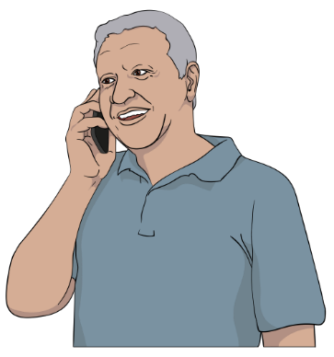
Ka āhei koe ki te whakapā atu ki te tira tatauranga mā te Waea Koreutu ki:

0800 236 787

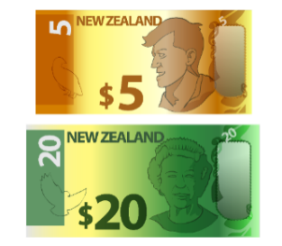
Ko te tikanga o Freephone, kāre kau he utu o tō tuku waea ki tēnei tau waea.

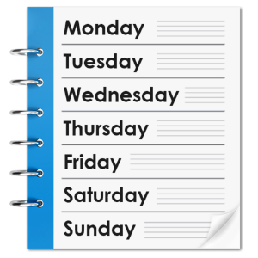
Mai i te 1 Paengawhāwhā ki te 30 Pipiri 2023 ka tuwhera te waea kōrero:

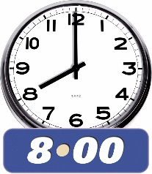
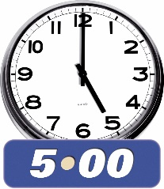
- 7 rā i te wiki / ia rā

- 8 am i te ata ki te 5 pm i te ahiahi.

Mehemea e kōrero ana koe i tētahi reo ehara i te reo Ingarihi, ka taea e koe te tono mō tētahi tangata kōrero i:
- Te Reo Māori
- Hāmoa
- Tonga
- Te Reo Mandarin

- Kanatonīhi

- Kōriana

- Hiniri
- Puniapi.
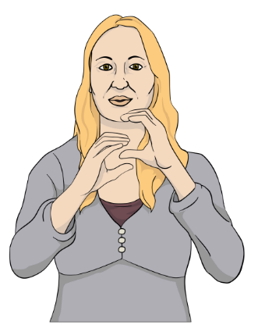
Ka taea e koe te rapu i ētahi atu kōrero mō te tatauranga i Te Reo Rotarota o Aotearoa i tō mātou pae tukutuku:

www.census.govt.nz

Mehemea he uaua ki a koe te whakamahi i te waea ko te ratonga o New Zealand Relay tētahi ratonga mā te hunga:

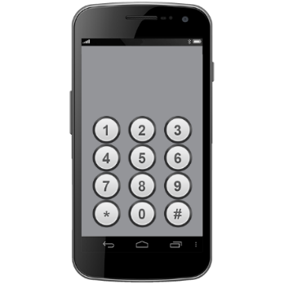
- Turi / he uaua te rongo kōrero

- turi, kāpō hoki

- ngoikore te kōrero / he uaua ki a rātou te kōrero

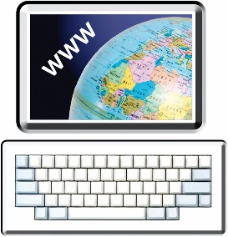
Ka taea e koe te rapu i ētahi atu kōrero mō te ratonga New Zealand Relay ki:

www.nzrelay.co.nz
Ka taea hoki te peka mai ki tō mātou pae tukutuku ki:

www.census.govt.nz

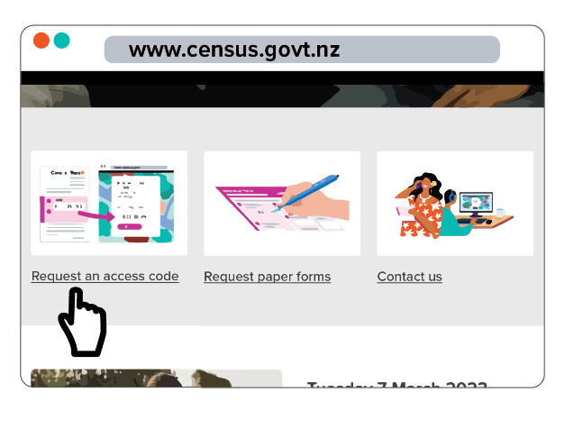
Kia tae ki tā mātou pae tukutuku ka taea te:

- tono waehere uru hou mā te pāwhiri ki: Tono waehere uru

- tono puka pepa mā te pāwhiri ki: Tono puka pepa

- tuku pātai mai, mā te pāwhiri ki: Whakapā mai ki a mātou.

I tuhia tēnei aratohu e Tatauranga Aotearoa.

Kua hurihia te reo ki te tikanga Pānui Māmā, i runga anō i ngā tohutohu a te ratonga Make It Easy o People First New Zealand Inc. Ngā Tāngata Tuatahi.

Ehara i te mea ko ngā whakaaro i tēnei puka ngā whakaaro o People First New Zealand Inc. Ngā Tāngata Tuatahi.
Ka whakamahia e Make It Easy he whakaahua mai i:

- SGC Image Works.

- Photosymbols.com

Ka whakamahi tēnei puka i ngā whakaahua i tukua mai e Tatauranga Aotearoa.

Ko ngā whakaahua ka whakamahia i tēnei puka Easy Read he mea here ki ngā ture manatārua, ā, kāore e taea te whakamahi, ki te kore e āta whakaaetia i te tuatahi.

