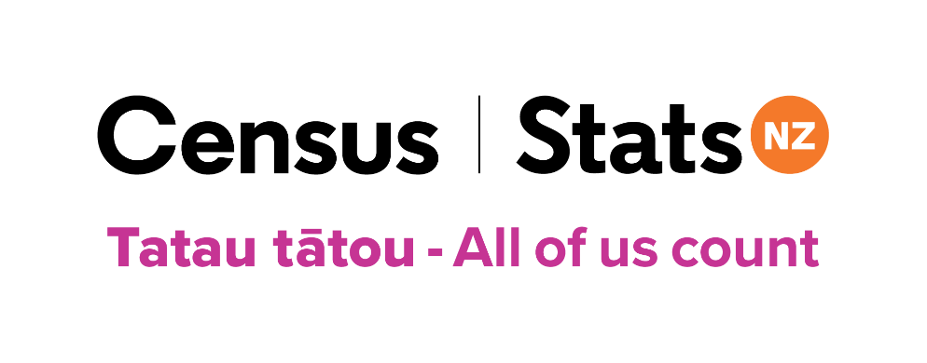
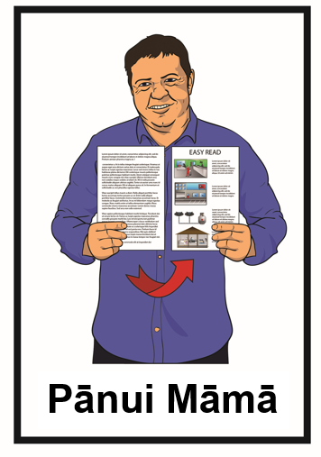

He aratohu Pānui Māmā mō te mahi i tō Tatauranga 2023
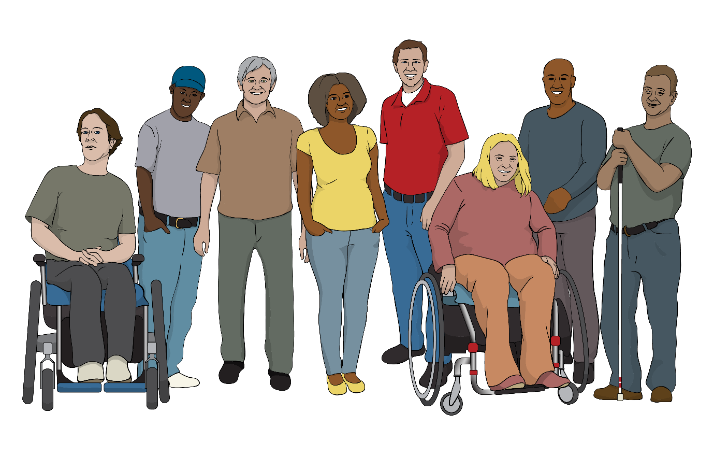

Tatau tātou – All of us count

He aha ngā kai o roto i tēnei pukapuka

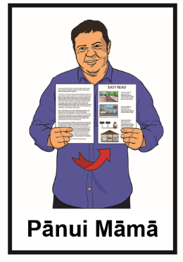
Nama whārangi:

Mō te aha tēnei pukapuka ……….…4

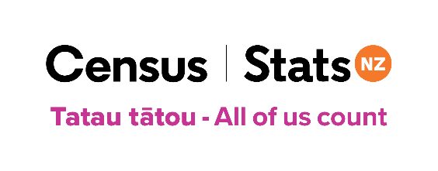
He aha te tatauranga? ..7

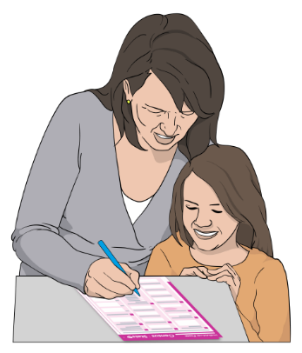
Ko wai mā ngā tāngata me whakakī i te tatauranga? 9

Te kimi tautoko hei whakakī i te tatauranga ……………………..11
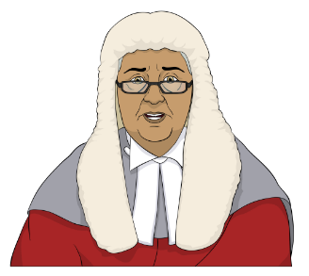

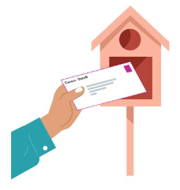
Ka ahatia ahau mehemea kāore au e whakakī i āku puka tatauranga? 15

Ka pēhea koe e whiwhi ai i ō puka tatauranga 16
Nama whārangi:

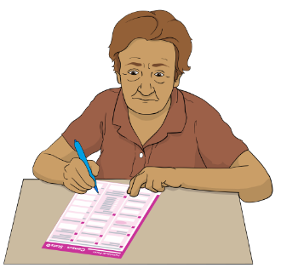
Āhea koe ka whakakī i ō puka tatauranga 19

Ngā puka tatauranga 20
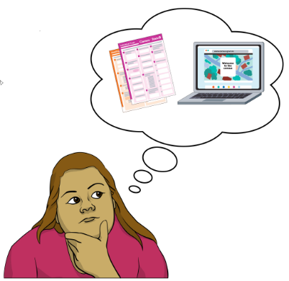

I mua i tō tīmata i tō tatauranga 24

Ngā mea ka hiahiatia e koe hei whakakī tuihono i ō puka tatauranga 25

Te whakakī tuihono i ō puka tatauranga 29
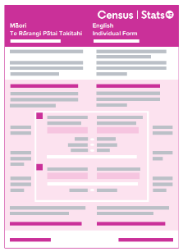

Te whakakī i ō puka tatauranga pepa 35

Nama whārangi:

Te whakahoki i ō puka tatauranga pepa 39
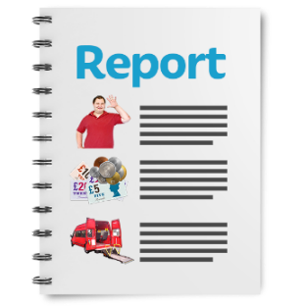

Ka ahatia ō kōrero e mātou 40

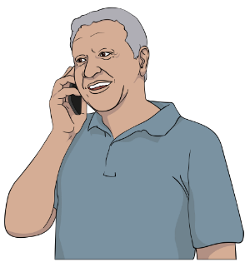
Me pēhea te whakapā mai ki te tīma tatauranga 42

Mō te aha tēnei pukapuka

Ko tēnei pukapuka Pānui Māmā he pukapuka mō te Tatauranga 2023.

Ko tēnei mea te tatauranga he wā e pātaingia ai ētahi pātai ki a koe mō ngā mea pēnei i:

- ko wai koe

- e hia ngā tāngata e noho tahi ana me koe.

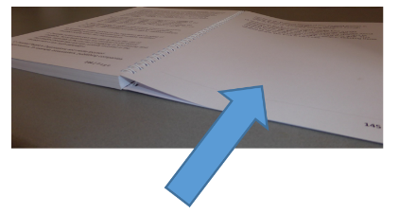
Ka taea e koe ētahi atu kōrero te kite mō te āhua o te tatauranga kei ngā whārangi 7-8 o tēnei pukapuka.

Kua oti tēnei mōhiotanga te tuhi e Tatauranga Aotearoa.

Ko Tatauranga Aotearoa te hinonga kāwanatanga e whakahaere ana i te Tatauranga 2023.
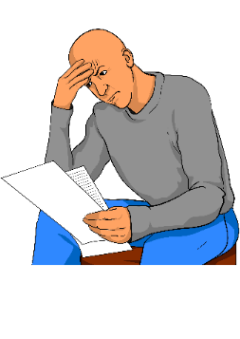
He pukapuka roa tēnei.

Ahakoa e tuhia ana hei Pānui Māmā, he uaua mā ētahi tāngata te pānui pukapuka pēnei te roa.

Ko ētahi o ngā mea ka taea hei whakamāmā ake i tēnei āhua:
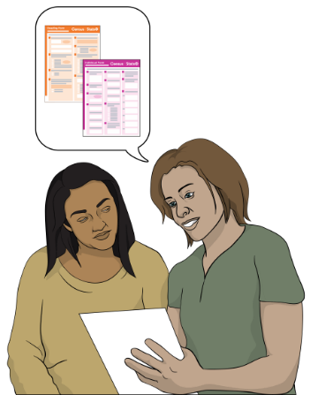
- pānuitia ētahi whārangi ruarua i te wā kotahi

          - rapua he tangata hei tautoko i a koe, kia mārama koe ki ngā kōrero o roto.

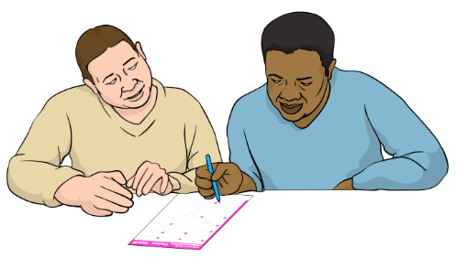
Ka taea te rapu tāngata pēnei i:

          - tētahi hoa

          - tētahi mema whānau.

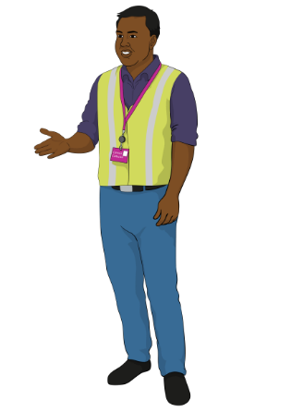
Ka taea hoki e koe te inoi ki tētahi kaikohikohi tatauranga hei tautoko i a koe kia mārama koe ki tēnei pukapuka.

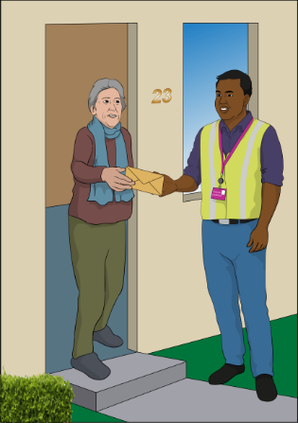
Ko tēnei mea te kaikohikohi tatauranga he tangata ka āhei pea ki te:

- haere mai ki tō kāinga

- tautoko i a koe kia mārama koe ki ngā mōhiotanga i roto i tēnei pukapuka

- tautoko i a koe ki te whakakī i ō puka tatauranga.

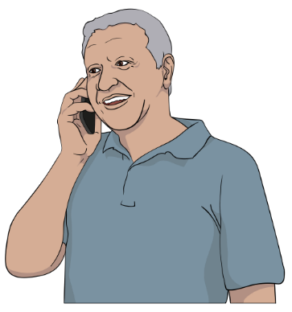
Kia tono ki tētahi kaikohikohi tatauranga hei tautoko i a koe ki te whakakī i ō puka tatauranga, me kōrero ki te tīma tatauranga.

Kei ngā whārangi 42 ki 44 i tēnei puka ka kitea e koe ētahi mōhiotanga mō te kōrero ki te tīma tatauranga.

He aha te tatauranga?

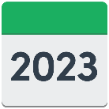
Ko tēnei mea te tatauranga:

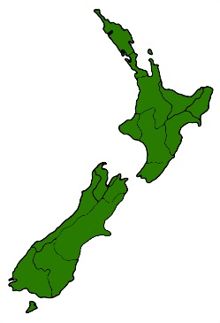
  - ka mahia ia 5 tau

- te ara e kimi mōhiotanga ai tātou mō ngā tāngata o Aotearoa.

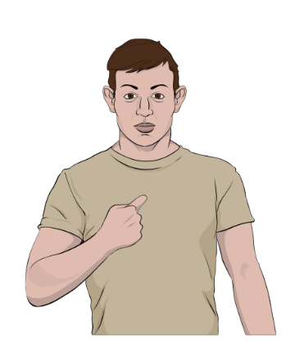
Ka mahia te tatauranga mā te whakamahi i ngā puka e pātai ana i ētahi pātai:

  - mōu

  - mō te wāhi e noho nā koe.
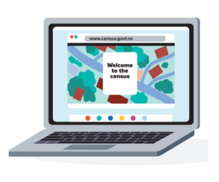

Ka taea e koe te mahi i te tatauranga mā te whakakī i:

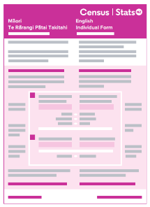
- ētahi puka tuihono

tēnei rānei

- ētahi puka pepa.
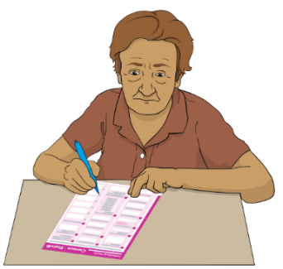
Ka taea e koe te kōwhiri ko tēhea te puka e hiahia ana koe ki te whakakī.
He rite tonu ngā pātai i ngā puka tatauranga tuihono / pepa.

Ko ngā āhuatanga ka kitea e Tatauranga Aotearoa i roto i te tatauranga, ka whakamahia hei whakamahere i ngā mea pēnei i:
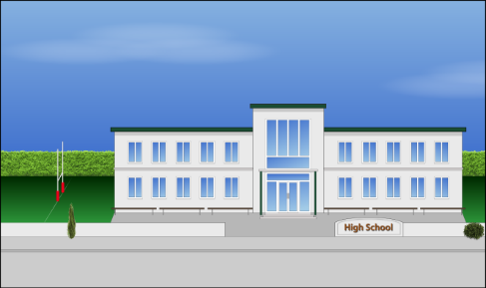
- te taurimatanga hauora

- ngā kura
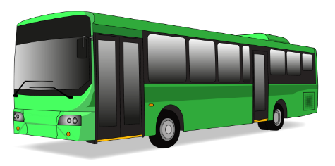
- te whai whare

- ngā pahi me ngā tereina
- te hanga rori

- ngā whare mō te iwi whānui pēnei I ngā whare pukapuka.

Ko wai mā ngā tāngata me whakakī i te tatauranga?

E kī ana te ture me whakakī ngā tāngata katoa i Aotearoa i te tatauranga.

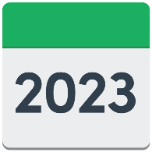
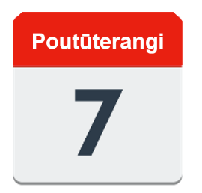
Ko te rā o te tatauranga ko te Rātū 7 Poutūterangi 2023.

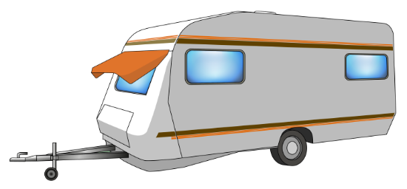
Me mātua whakakī koe i te tatauranga ahakoa:

    - e noho ana koe i tētahi wāhi ehara i te whare
    - kei roto koe i te hōhipera

    - kāore he kāinga noho tūturu
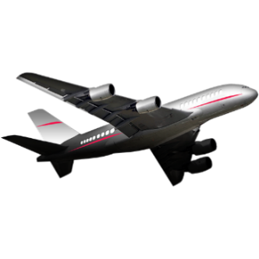
    - e noho ana i tētahi kāinga ā-rōpū

    - he manuhiri koutou ki Aotearoa.
Mehemea he tamariki āu me whakakī koe i ā rātou puka mō rātou.

Te kimi tautoko hei whakakī i te tatauranga

Ki te hiahia koe ki ētahi tautoko hei whakakī i te puka tatauranga ka taea e koe te pātai ki tētahi tangata pēnei i tētahi:
- hoa

- mema whānau

- kaikohikohi tatauranga.

Mehemea e kōrero ana koe i tētahi reo ehara i te reo ingarihi, ka taea e koe te tono mō tētahi tangata kōrero i:

- Te reo Māori

- Te reo Hāmoa

- Te Reo o Tonga

- Te Reo Manatarīni.

Mehemea e kōrero ana koe i tētahi reo ehara i te reo ingarihi, ka taea hoki e koe mō tētahi tangata kōrero i:

- Te Reo Kanatonīhi

- Te Reo Koriana

- Te Reo Hiniri

- Te Reo Puniapi.

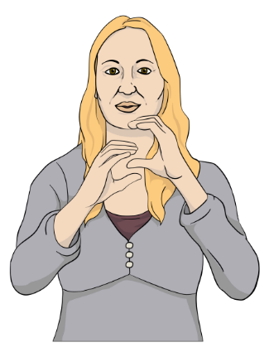
Ka taea e koe te rapu i ētahi atu kōrero mō te tatauranga i Te Reo Rotarota o Aotearoa i tō mātou pae tukutuku:

www.census.govt.nz

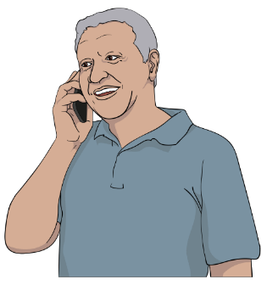
Ka taea e koe te tono āwhina i tētahi tangata nō te tatauranga, kia whakakīa ō puka whakamātau tatauranga.

Kei ngā whārangi 42 ki 44 i tēnei puka ka kitea e koe ētahi mōhiotanga mō te kōrero ki te tīma tatauranga.

Mehemea he uaua ki a koe te whakamahi i te waea, kei te wātea te New Zealand Relay Service mā te hunga:

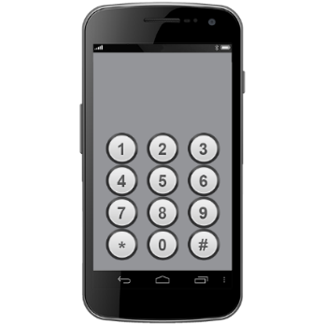
- turi / uaua te rongo kōrero

- turikāpō

- he uaua te kōrero ki a rātou.

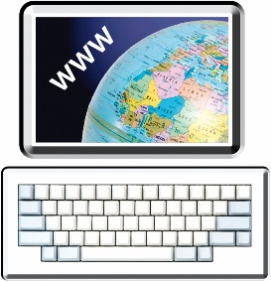
Ka taea e koe te rapu i ētahi atu kōrero mō te ratonga New Zealand Relay ki:

www.nzrelay.co.nz

Ka ahatia ahau mehemea kāore au e

whakakī i āku puka tatauranga?

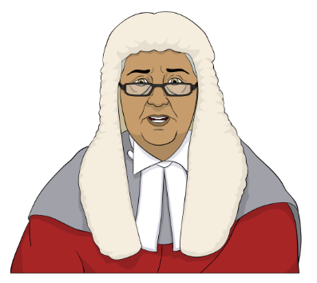
Mehemea kāore koe e whakakī i ō puka tatauranga ka:

  - hāmenetia pea koe kia haere ki te kōti
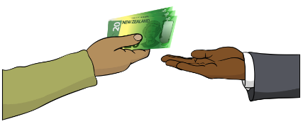
  - whāinatia pea tae atu ki te 2 mano tāra / $2000.
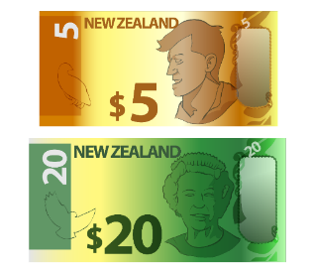

Ko tēnei mea e te whāina he moni ka utua e koe ki te kāwanatanga mō te takahi ture.

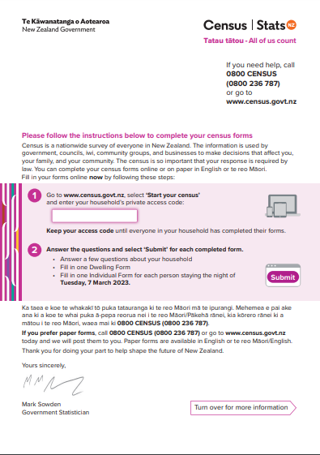
Ka pēhea koe e whiwhi ai i ō puka tatauranga

Ka tukua he reta ki a koe mō te tatauranga.

I ētahi takiwā ka peka atu mātou ki tō kāinga ki te hoatu i ēnei ki a koe:

  - he reta

  - ō puka tatauranga.

Ka pēnei pea ā mātou tikanga tuku ki a koe:

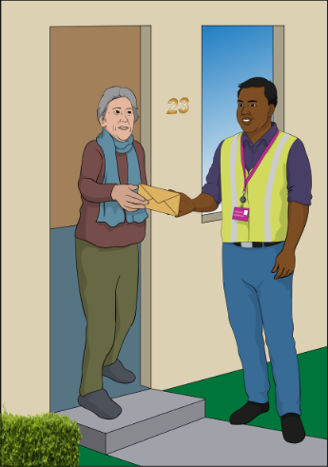
  - ka meatia ki roto i tō pouaka mēra

tēnei rānei

  - ka pātōtō ki tō kūwaha ki te hoatu i ngā mea nei ki a koe.

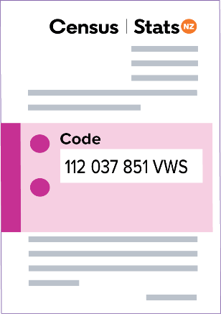
Mō ētahi tāngata, ka tukua he reta whai waehere uru anake ki a rātou.

Mā tēnei mea te waehere uru ka taea e koe te whakakī tuihono i ngā puka tatauranga.

Ka kitea ēnei i tō waehere uru:

  - he pū / reta
112 037 851 VWS

  - he tau / nama.
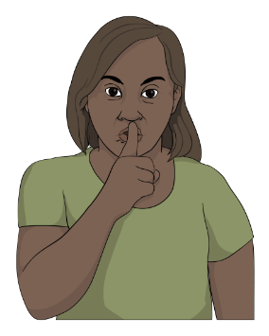

Kaua e tohaina tēnei waehere uru ki tētahi tangata kāore e noho ana i tō kāinga.

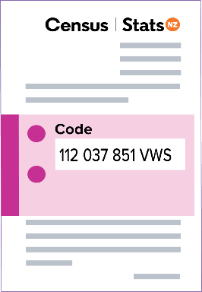
Me āta pupuru te reta me tō waehere uru ki tētahi wāhi haumaru.

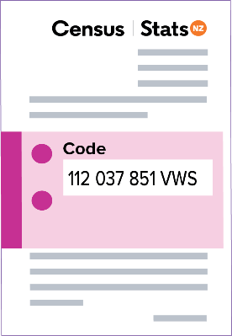
Me pupuru e koe tō waehere uru kia oti rā anō te whakakī o ngā tāngata katoa o tō whare i tāna puka.

Ki te kore koe e hiahia ki te whakakī tuihono i ngā puka tatauranga, ka taea te whakapā atu ki te tīma tatauranga.

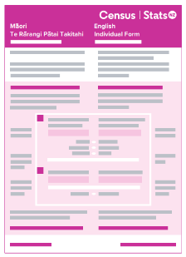
Ka taea e te tīma tatauranga te tuku puka pepa, ki te tonoa e koe.

Ko ngā puka pepa e 3 ka taea e koe te kōwhiri, inā:

  - Te reo Ingarihi
  - Te reo Ingarihi me Te reo Māori

  - Tānga nui ki Te reo Ingarihi.

Āhea koe ka whakakī i ō puka tatauranga

Me whakaoti koe i ō puka tatauranga hei te Rātū 7 Poutūterangi 2023 i mua mai rānei.

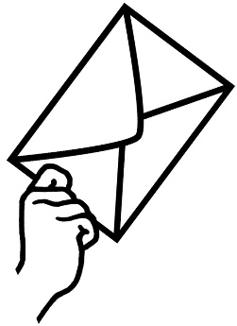
Ki te kore koe e whakakī i ō puka tatauranga ka tukua e mātou tētahi reta whakamahara i a koe kia whakakīa.

I ētahi rohe o Aotearoa ka peka atu mātou ki a koe ki te:
  - whakamahara i a koe kia whakakī i ō puka tatauranga

  - ui atu ki a koe kia rongo mehemea kei te hiahia tautoko koe ki te whakakī i ō puka tatauranga.

Ngā puka tatauranga

E 2 ngā puka tatauranga me whakakī e koe:

- Te Rārangi Pātai mō te Whare Noho

2. Te Rārangi Pātai Takitahi.

Ko tā Te Rārangi Pātai mō te Whare Noho he whakaatu mai i ngā kōrero mō tō kāinga noho.

Ko tēnei mea te whare noho, he wāhi e noho ana he tangata i roto, pēnei i tētahi:

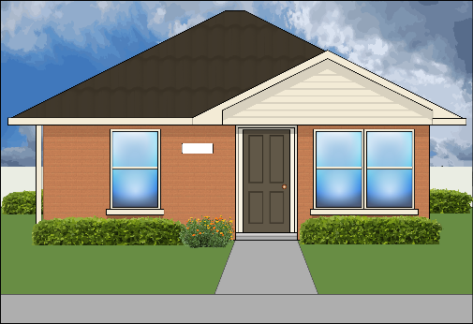
- whare

- whare wīra

- tēneti.

Ko ngā pātai o roto o Te Rārangi Pātai mō te Whare Noho he pēnei:

- e hia ngā rūma moe o tō kāinga noho?

- he hononga ipurangi kei tō kāinga?

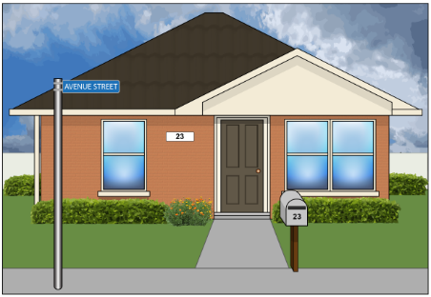
Ko ētahi tāngata he maha kē atu i te kotahi te whare noho i te kāinga poutāpeta, pēnei i:

- te whare

me

- tētahi whare wīra / rūma moe o waho / whare kaumātua.
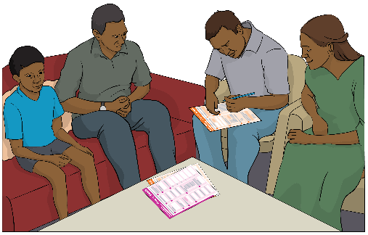

Me whakakī 1 tangata mai i ia whare noho i tētahi Rārangi Pātai mō te Whare Noho.

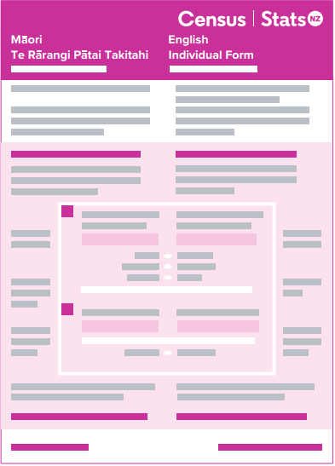
Ko tā te Rārangi Pātai Takitahi he whakaatu mai i ngā kōrero mōu.

Ko ngā pātai o roto o Te Rārangi Pātai Takitahi he pēnei:

- i whānau koe i hea?

- ka kōrero koe i ēhea reo?

- pēhea tō whai i te mātauranga / mahi?
- e hia te moni ka utua ki a koe?

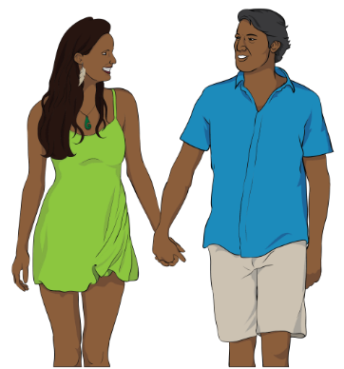
- he aha te momo waka ka whakamahia e koe kia ako / haere ki te mahi?

- he hoa piri pūmau tōu?

Ko ngā tāngata katoa e noho ana i tō kāinga ka:

- whiwhi Rārangi Pātai Takitahi hei whakakī

- whakamahi i te waehere uru taurite.

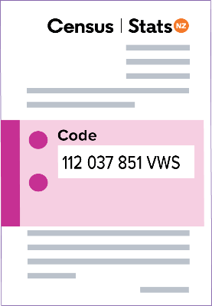
Tiakina tō waehere uru kia oti rā anō te whakakī o ngā tāngata katoa o tō whare i tāna puka.

I mua i tō tīmata i tō tatauranga

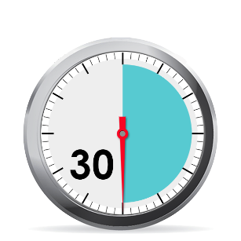
Me mātua whakarite koe i tētahi wā wātea 30 meneti, kaua e iti iho, hei whakakī i ō puka tatauranga.

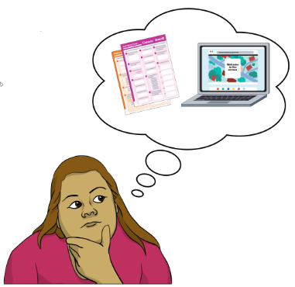
Me mātua kōwhiri koe mehemea e hiahia ana koe ki te whakakī i ngā puka tatauranga:

- mā te whakakī tuihono

- mā te pepa.

Ngā mea ka hiahiatia e koe hei whakakī

tuihono i ō puka tatauranga

Ki te hiahia koe ki te mahi tuihono i te tatauranga, me mātua whai pūrere ka āhei ki te uru ki te ipurangi pēnei i tētahi:

- waea atamai

- rorohiko pona

- paparorohiko.

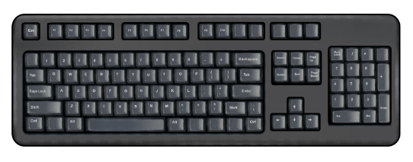
Ka hiahia hoki koe ki:

- tētahi mea hei patopato pēnei i te papapātuhi

- tētahi hononga ki te ipurangi

- tō waehere uru.

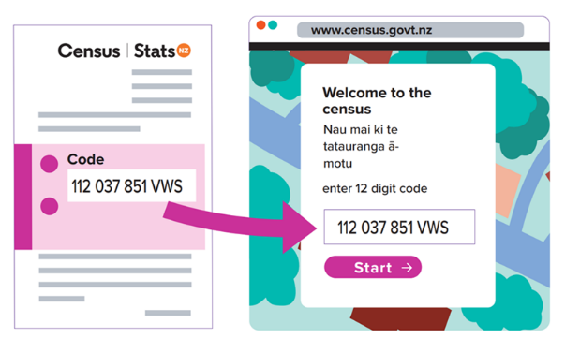
Ko tō waehere uru, kei te whārangi o mua o te reta tatauranga.

Ka kitea ēnei i tō waehere uru:

- he pū (reta)

- he tau (nama).

Mā tō kāinga anake tō waehere uru.

Kaua e tohaina tēnei waehere uru ki tētahi tangata kāore e noho ana i tō kāinga.

Ka taea e koe te toha tēnei waehere ki tētahi kāore e noho tahi ana me koe, mehemea ko ia kei te tautoko i a koe ki te whakakī tuihono i te puka tatauranga.

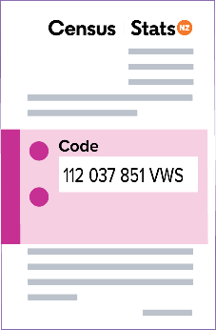
Me pupuru e koe tō waehere uru kia oti rā anō te whakakī o ngā tāngata katoa o tō whare i tāna puka.

Me mātua whai ia whare i taua kāinga i tōna ake waehere uru.

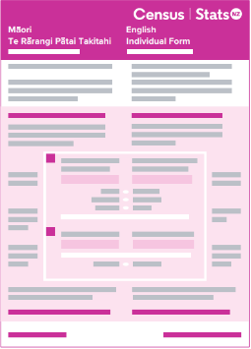
Mehemea he whare kē anō tōu / he whare wīra anō / he whare whāiti kei tō kāinga e noho ana tētahi tangata i roto, me mātua whiwhi tērā i tōna anō:
187 069 257 HYT

- waehere uru

- puka tatauranga.

Ki te hiahia koe ki tētahi atu waehere uru ka taea e koe te whakamahi te puka i te paetukutuku tatauranga e karangatia nei:

Tonoa he waehere uru i te ipurangi.
Ko te pae tukutuku o te tatauranga ko:

www.census.govt.nz

Ka taea hoki e koe te waea atu ki te tīma tatauranga ki te tono waehere uru anō:

Waea: 0800 236 787
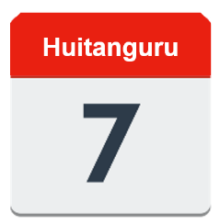
Ka tuwhera te waea atu i te Rātū 7 Huitanguru 2023.
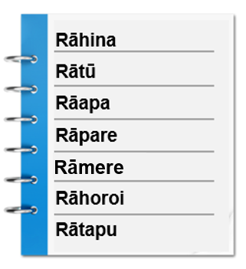

Ka tuwhera te waea:

- 7 rā i te wiki / ia rā
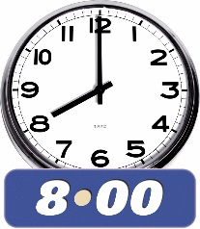
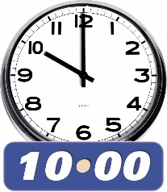
- 8 am i te ata ki te 10 pm i te ahiahi

Te whakakī tuihono i ō puka tatauranga

E taea ai e koe te whakakī tuihono i ō puka tatauranga me mātua whakatuwhera koe i tētahi pūtirotiro ipurangi i tō pūrere.

Ko tēnei mea te pūtirotiro ipurangi he taupānga e āhei ai koe ki te whakamahi i te ipurangi.

Ko ngā pūtirotiro he papatono pēnei i:
- Google Chrome
- Microsoft Edge
- Safari.

Me mātua whakamahi koe i tō pūtirotiro ipurangi kia haere ki te pae tukutuku tatauranga ki:

www.census.govt.nz

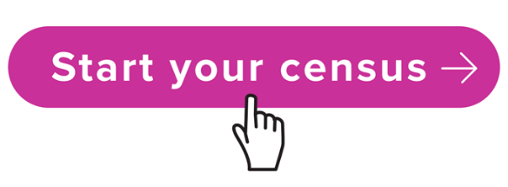
I tō mātou pae tukutuku ka kitea e koe tētahi pātene e kī ana Start your census.

Pāwhiritia te pātene Start your census.

Ka tonoa koe i reira kia hoatu i tō waehere uru.

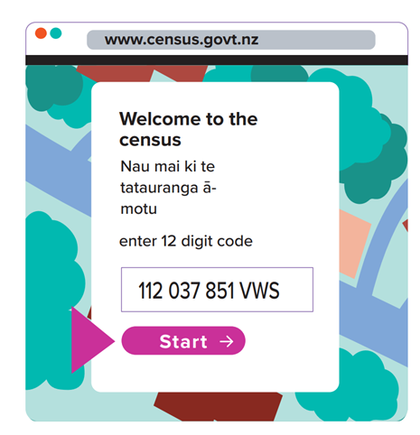
Patohia tō waehere uru ki roto i te pouaka i te mata.

Pāwhiritia te pātene Tīmata kia tīmata ki te whakakī i ō puka tatauranga.

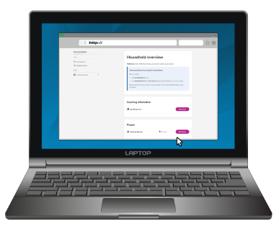
Mō ngā puka tuihono me kōwhiri koe i tētahi tangata 1 e noho ana i tō kāinga hei whakakī i te Puka Whakarite Whare.

Ko te kī a te Puka Whakarite Whare ki a mātou:

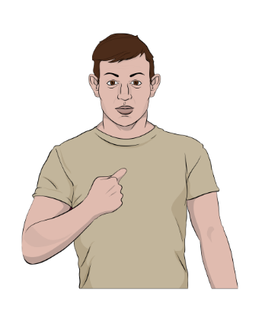
- kei whea tō kāinga noho

- ngā ingoa o ngā tāngata katoa e noho ana i tō kāinga.

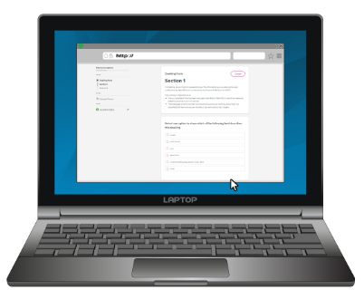
Me mātua whakaoti te Puka Whakarite Whare i mua i te whakakī i te:

- Rārangi Pātai mō te Whare Noho

- Ngā Rārangi Pātai Takitahi.

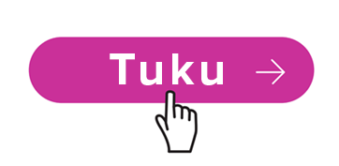
Kia oti te Puka Whakarite Whare, pāwhiritia te pātene e kī ana Tuku.

Kia oti te pātene Tuku te pāwhiri, e kore e taea e koe:

- te panoni ō whakautu

- te pānui ō whakautu.

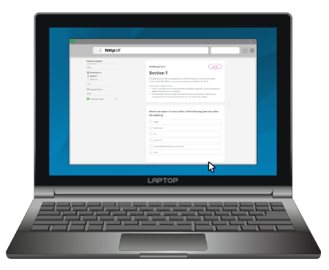
Me kōwhiri koe i tētahi tangata 1 e noho ana i tō kāinga hei whakakī i te Rārangi Pātai mō te Whare Noho.

He pai tonu mehemea ko te tangata tonu tēnei nāna Te Puka Whakarite Whare i whakakī.

Kia oti i a ia te whakakī te Rārangi Pātai mō te Whare Noho, me pāwhiri te pātene e kī ana Tuku.
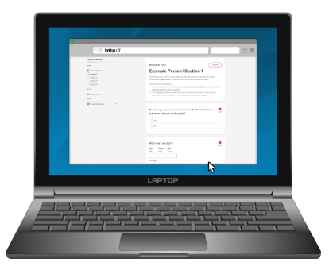
Ka taea e koe te tīmata ki te whakakī i te Rārangi Pātai Takitahi mehemea kua oti kē i a koe, i tētahi atu tangata rānei i tō whare te whakaoti i te:

- Te Puka Whakarite Whare

- Te Rārangi Pātai mō te Whare Noho.

Kia oti i a koe te whakakī tō Rārangi Pātai Takitahi, me pāwhiri te pātene e kī ana Tuku.

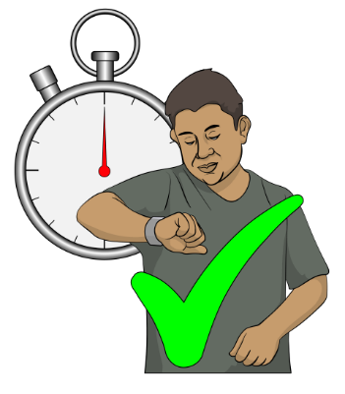
Kia ngana ki te whakaoti i te puka, kāore he okiokinga, mehemea ka taea.

Ki te mea me okioki koe, kaua e katia te whārangi tukutuku kei reira te puka tatauranga.

Ki te katia e koe te whārangi tukutuku ka tonoa koe kia tīmata anō i te puka tatauranga.
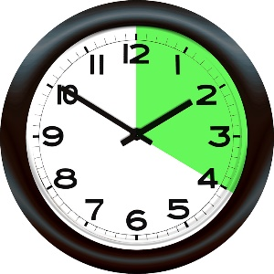
E kore e taea te okioki neke atu i te 20 meneti.

Ki te okioki koe neke atu i te 20 meneti e kore te puka e tiaki i tāu i pato ai i mua.

Te tikanga o tēnei, me tahuri koe ki te tīmata anō i te puka tatauranga.

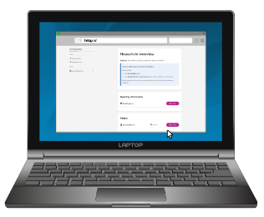
Kua oti i a koe te tatauranga kia oti ngā puka e 3 katoa te tuku:

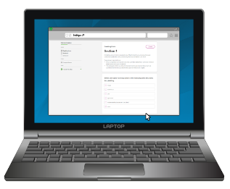
- Te Puka Whakarite Whare
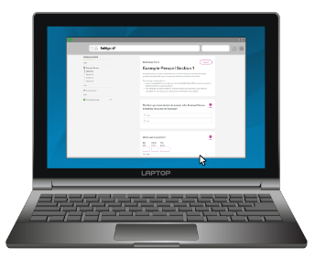
- Te Rārangi Pātai mō te Whare Noho

- Te Rārangi Pātai Takitahi.

Filling out your census paper forms

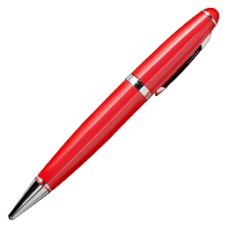
Ina whakakī koe i ō puka tatauranga pepa, me whakamahi e koe tētahi pene:

- pango
tēnei rānei

- kikorangi.

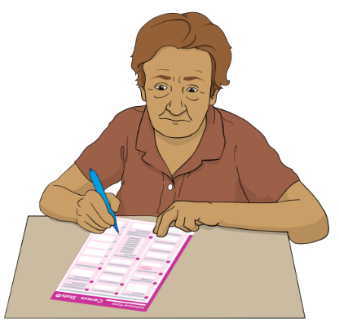
Me tuhi ō whakautu ki tētahi o ēnei reo:

- Te Reo Ingarihi

tēnei rānei

- Te reo Māori.

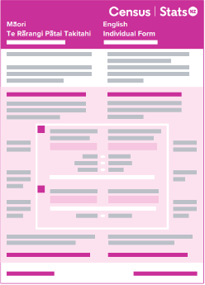
Ina whakakī koe i ō puka tatauranga pepa, me mātua:

- tuhi i ngā mea katoa ki ngā PŪ MATUA hei tauira:
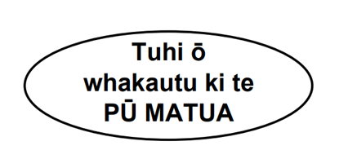
TŌ INGOA

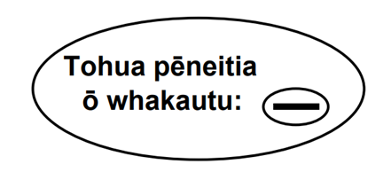
- tohu i ngā pātai ki tētahi tohuhono, pīhono rānei, kia pēnei te āhua:
–

Kaua e tuhi tohu ki ngā puka tatauranga mā te whakamahi i ngā:

- tiki /

- rīpeka / x
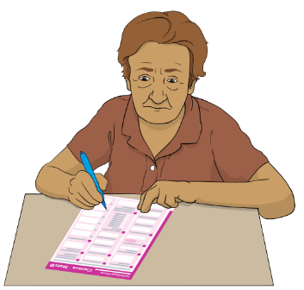
Ina whakakī koe i ō puka tatauranga pepa, me mātua
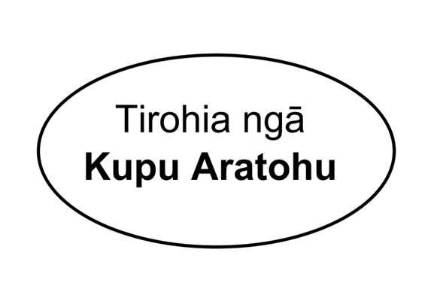
- pānui ia pātai

- whakautu ia pātai

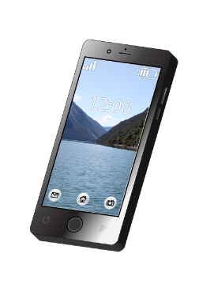
- pānui ngā Kupu Aratohu mehemea kāore koe i te tino mārama me pēhea

- tuhi i tō nama waea i te puka

- waitohu i tō ingoa i te mutunga o te puka.
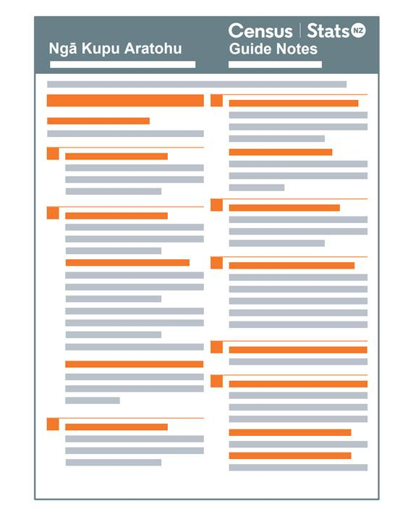

Ko Ngā Kupu Aratohu tētahi puka iti kei reira ētahi mōhiotanga mō te mahi i ngā kupu aratohu.

Me i noho mai tētahi tangata ki te tautoko ki te whakakī i ō puka pepa, ka taea e ia te waitohu mōu.

Ka whakamahia e mātou te nama waea ka tuhia e koe, hei whakapā atu ki a koe.

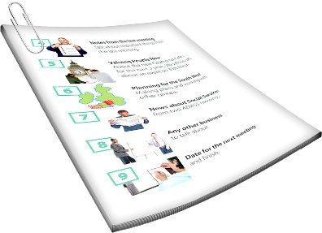
Ka whakamahia e mātou taua nama waea mehemea e hiahia ana mātou ki te inoi kia whai wāhi koe ki tētahi atu uiuinga, ka tū i muri i te tatauranga, pēnei i te Uiuinga Hauātanga o Aotearoa.

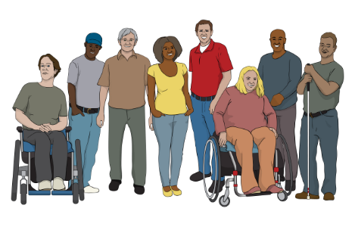
Ka kitea e Te Uiuinga Hauātanga o Aotearoa ētahi kōrero mō te hunga whai kaha.

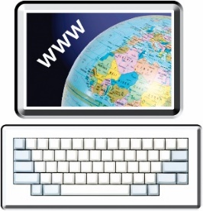
Ka taea hoki te pānui mō ētahi atu āhuatanga o Te Uiuinga Hauātanga o Aotearoa i tō mātou pae tukutuku ki:
www.stats.govt.nz/topics/disability

Te whakahoki i ō puka tatauranga pepa

Ka tukua e mātou he pūkoro tuku kore utu me ō puka pepa.

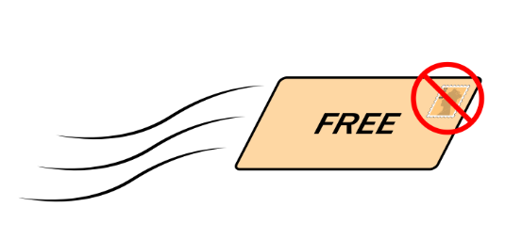
Ko tēnei mea te pūkoro kore utu he pūkoro e āhei ai koe te tuku mēra, kāore e mate ki te utu mō tētahi panekuīni.

Ka taea e koe te whakapā atu ki te tīma tatauranga, ki te hiahia koe ki tētahi kaikohikohi tatauranga kia tiki atu i ō puka tatauranga.

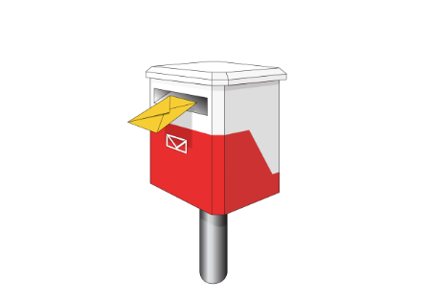
Kua oti katoa tō tatauranga ina pēneitia ngā puka e 2:

- ka tukua ki te tatauranga

- ka tīkina atu e tētahi kaikohikohi tatauranga.

Ka ahatia ō kōrero e mātou

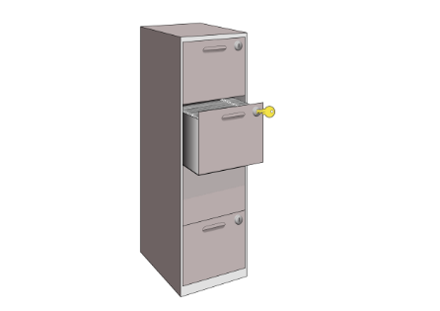
E kī ana te ture i Aotearoa, ko ngā kōrero katoa ka homai e koe me mātua tiaki kia:

- matatapu

- haumaru.

Ko te tikanga o tēnei mea, kia matatapu, e kore mātou e toha i tētahi o ō kōrero whaiaro ki ētahi atu:

- tāngata

- rōpu.

Ko ngā kōrero whaiaro ko ngā mea pēnei i tō ingoa.

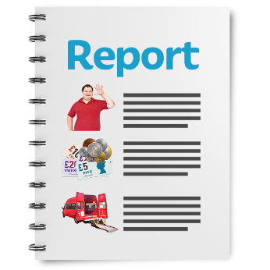
Ka whakamahia e Tatauranga Aotearoa ngā mea i kitea i roto i te tatauranga hei tuhi tauanga mō ngā hapori o Aotearoa.

Ko ngā tauanga he tau (nama) e mōhio ai mātou ki ngā āhuatanga pēnei i te tokomaha o:

- ngā tāngata e noho ana i tētahi tāone nui
- ngā tamariki kei tētahi kura tūtata

- ngā tāngata o Aotearoa whai hauātanga.

Ina tukua e mātou ā mātou tauanga te pānui e ētahi atu tāngata, ka mahi nui mātou kia kore ai e taea e te tangata te:
- mōhio ko wai koe

- mōhio he aha ō whakautu i te tatauranga.

Me pēhea te whakapā mai ki te tīma tatauranga

Ka āhei koe ki te whakapā atu ki te tīma tatauranga mehemea:

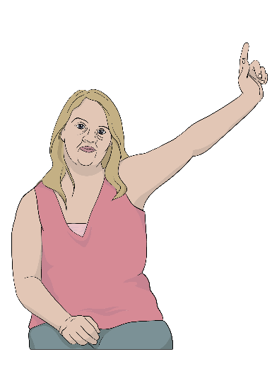
- he pātai āu

- e hiahia ana ki ētahi puka pepa

- e hiahia ana koe ki tētahi kaikohikohi tatauranga hei tautoko i a koe.
Ka taea e koe te whakapā mai ki a mātou mā Freephone ki:

0800 236 787

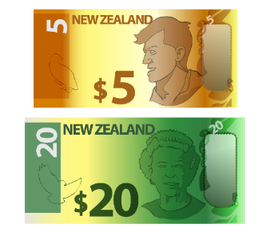
Ko te tikanga o Freephone, kāre kau he utu o tō tuku waea ki tēnei tau waea.
Ka tuwhera tēnei waea atu i te Rātū 7 Huitanguru 2023.

Ka tuwhera te waea:

- 7 rā i te wiki / ia rā

- 8 am i te ata ki te 10 pm i te ahiahi.

Ka taea hoki te peka mai ki tō mātou pae tukutuku ki:

www.census.govt.nz

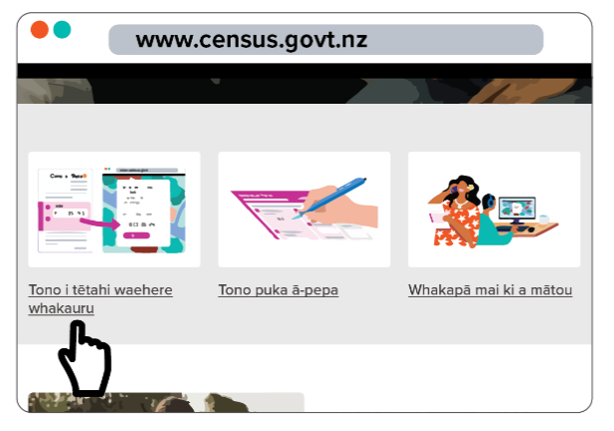
Kia tae ki tā mātou pae tukutuku ka
taea te tono:

- te tono i tētahi waehere whakauru hou mā te pāwhiri ki: Tono i tētahi waehere whakauru

- puka tatauranga pepa mā te pāwhiri ki: Te tono puka

- he pātai, mā te pāwhiri ki: Whakapā mai ki a mātou.

I tuhia tēnei aratohu e Tatauranga Aotearoa.

Kua hurihia te reo ki te tikanga Pānui Māmā, i runga anō i ngā tohutohu a te Make It Easy Kia Māmā Mai service o People First New Zealand Inc. Ngā Tāngata Tuatahi.

Ehara i te mea ko ngā whakaaro i tēnei puka ngā whakaaro o People First New Zealand Inc. Ngā Tāngata Tuatahi.

Ka whakamahia e Make It Easy he whakaahua mai i:

- SGC Image Works
- Photosymbols.com.

Ka whakamahi tēnei puka i ngā whakaahua i tukua mai e Tatauranga Aotearoa.

Ko ngā whakaahua ka whakamahia i tēnei puka Easy Read he mea here ki ngā ture manatārua, ā, kāore e taea te whakamahi, ki te kore e āta whakaaetia i te tuatahi.

